**Body language experts give their verdicts on Kamala Harris's first sit down interview: VP raised finger in 'gesture of authority' as she defended White House record but was 'deceptive' when asked about Joe Biden's decision to drop out**

30 Aug 2024, updated 13:39 EDT 30 Aug 2024 By James Reynolds and Chris Jewers

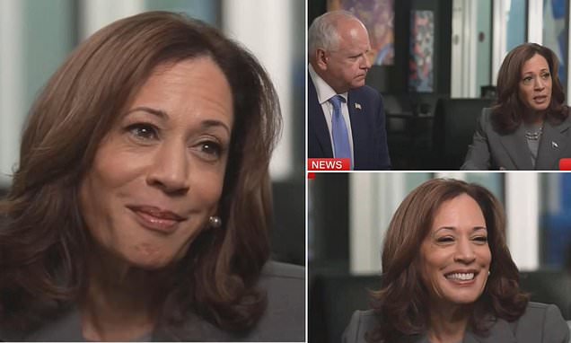

[Kamala Harris](https://www.dailymail.co.uk/news/kamala-harris/index.html) looked 'proud' and as she raised a finger in a 'gesture of authority' to defend the [White House](https://www.dailymail.co.uk/news/white-house/index.html)'s record in her first major TV interview of her campaign, but was 'deceptive' when asked about [Joe Biden](https://www.dailymail.co.uk/news/joe-biden/index.html)'s decision to drop out, body language experts have suggested.

[Judi James](https://www.dailymail.co.uk/tvshowbiz/judi-james/index.html), an analyst of communication and body language, judged that the Democratic hopeful answered questions on Thursday with a 'tone of curt decisiveness', embracing a 'new look of direct answers and power poses'.

However, she said the Vice President risked being 'knocked-off balance' when asked about why her positions on various key issues had changed since her last bid for presidency by [CNN](https://www.dailymail.co.uk/news/cnn/index.html)'s interviewer Dana Bash.

'She reels back in her seat and her eyes drop down in a cut-off as though unaware that relevant point would be raised,' Ms James told MailOnline today.

While Ms Harris has looked to 'signal authority' in her poses and manner of addressing her running mate, [Minnesota](https://www.dailymail.co.uk/news/minnesota/index.html) Gov. Tim Walz, her approach to [Donald Trump](https://www.dailymail.co.uk/news/donald_trump/index.html) appears to be acting 'as though he were still in office and she the opposition', Ms James said.

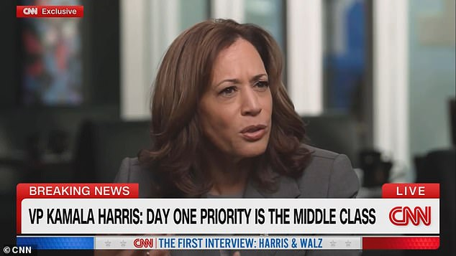

Harris has adopted a 'new look of direct answers and power poses', Ms James suggested

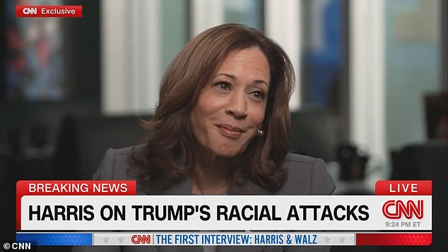

'She avoids speaking in the tone or pose of the incumbent, rolling her claims back at Trump as though he were still in office and she the opposition,' Ms James said

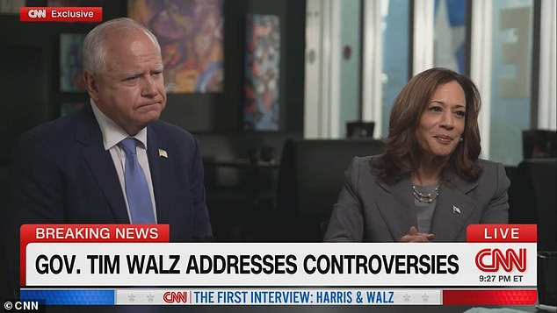

With her running mate Tim Walz (L), Harris' approach is 'very proud parent'

Kamala Harris appeared alongside Tim Walz on CNN on Thursday to spell out some of her political positions and give voters a better sense of what they might expect under her administration - in her first major sit down interview of her campaign.

Among other things, she spoke on her stance on Israel and positions on fracking and illegal immigration that appeared to have been reversed since she last stood for President in 2020, when she held more liberal stances on the issues.

[[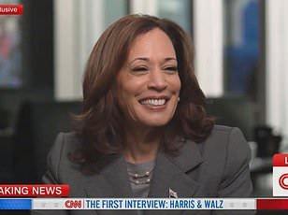](https://www.dailymail.co.uk/news/article-13795737/kamala-shift-centre-republican-stance-israel-gaza-immigration-donald-trump.html)](https://www.dailymail.co.uk/news/article-13795737/kamala-shift-centre-republican-stance-israel-gaza-immigration-donald-trump.html" \t "_blank)

Harris came into the interview from a position of strength, leading Trump 45 per cent to 41 per cent in a poll published by Reuters and Ipsos on Thursday, indicating 'new enthusiasm' among voters in the run-up to the November 5 election.

The Vice President was quizzed on what her first acts would be as President, giving a broad answer that CNN's reporter pushed back on.

'Well, there are a number of things. I will tell you, first and foremost, one of my highest priorities is to do what we can to support and strengthen the middle class,' she said.

'So, what would you do day one?' Bash insisted, moving Harris to talk about the 'opportunity economy' - a vague resolution that left critics unsatisfied.

'When asked what she would do on her first day in the White House her body language seems to suggest she has not set foot in the place so far,' Ms James analyzed.

'She looks up in reflection as though the thought were new to her before bringing her right hand up in a cut-off gesture to pretend to scratch her face with the back of her thumb.

'Her comments are non-specific, leading to the question being repeated, but she heaves the point of her answers into an attack on Trump, displaying facial expressions of pity, sorrow and concern for the middle classes and talking about "Turning the page on division" as though Trump were still in office.'

However, Harris' transformation into a political leader has seen her begin to adopt signals that convey authority, Ms James added.

'Her approach to Walz is very proud- parent and when she is pushed with some direct questions she brings out the right index finger raised in a gesture of authority, using it to conduct the interview before ending on the point that she had produced ‘Good work’ with a strong pursing of the lips to say "subject closed".'

During the interview, the Vice President continued to voice her loyalty towards incumbent President Biden and defending the White House's record.

She also looked to convey a sense of relatability, sharing how she was making bacon and pancakes for her nieces when he called to tell her he was dropping out of the race.

'Asked whether she has any regrets about supporting Biden staying in office her confidence returns as she raises her brows, shakes her head firmly and says "No, none at all",' Ms James said.

'But when his name first comes us there is a look of what could be fear in her eye expression and her brows pucker.

'She even re-arranges her shoulders as though going into battle at this point.

'Her speech of support for Biden sounds heartfelt and she re-directs into an attack on Trump.

'But her comments about turning the page on the last decade proves a too-tempting own goal for Bash, who points out she and Biden have been in office during that time too.'

Scott Rouse, a fellow body language expert, was more critical of Harris' signalling.

Speaking to Newsmax, he observed that Harris' 'bobblehead' moving from side to side indicated that she had 'inner dialogue going on'.

'We see tons of that with both of them, with Kamala Harris and Walz. They're thinking about what they're gonna say next...

'This is one of the ones where she's sort of on the fly, making this up as she goes.'

During the interview, Ms Harris said she had thought about Joe Biden before herself when she heard of his plans to drop out of the race.

'We're hearing what we call fading facts. As she talks, she gets quieter and quieter; she talks about how she was concerned with him.

'And quite often when someone's being deceptive, they get quieter as they get to their answer... we hear that here big time.

'We don't see any of the cues that let us know she's actually being sad... this is a put-on sad face,' he added.

The interview came as voters are still trying to learn more about the Democratic ticket in an unusually compressed time frame.

President Joe Biden ended his reelection bid just five weeks ago.

Harris hadn't done an in-depth interview since she became her party's standard-bearer five weeks ago, though she did sit for several while she was still Biden's running mate.

In Thursday's sit-down, she focused largely on policy, as Harris sought to show that she had adopted more moderate positions on issues that Republicans argue are extreme, while her running mate defended past misstatements about his biography.

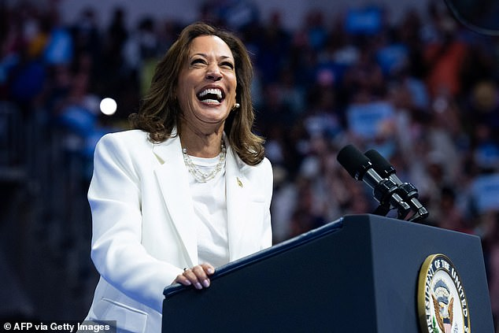

Kamala Harris speaks at a campaign rally at Enmarket Arena during a two-day campaign bus tour in Savannah, Georgia

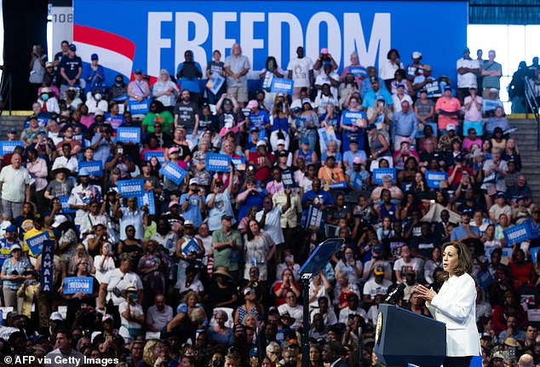

Harris took time to sit down for her first interview with CNN amid a tour in Georgia

Trump and Harris are set to debate on Sept. 10. In a post Thursday evening, it appeared Trump was paying close attention to the interview.

Democrats' enthusiasm about their vote in November has surged over the past few months, according to polling from Gallup.

About 8 in 10 Democrats now say they are more enthusiastic than usual about voting, compared with 55% in March.

This gives them an enthusiasm edge they did not have earlier this year. Republicans' enthusiasm has increased by much less over the same period, and about two-thirds of Republicans now say they are more enthusiastic than usual about voting.

According to a poll by Reuters and Ipsos published Thursday, Harris now leads Trump by 13 points among women and Hispanic voters - an increasing trends.

Trump still leads among white voters and men - but 73 per cent of Democrats said they were more excited after Harris entered the race.